1.a Film Title contains the word Uptown in any position.

1.b Film length is more than 120 minutes and rental rate is more than 2.99

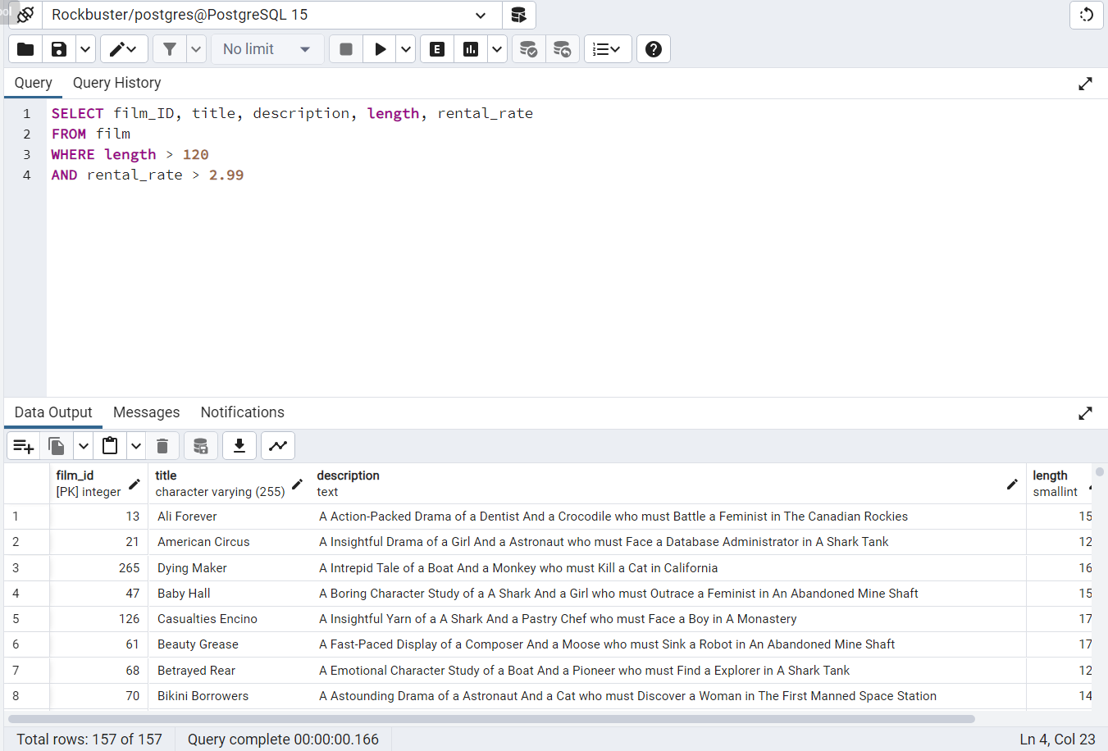

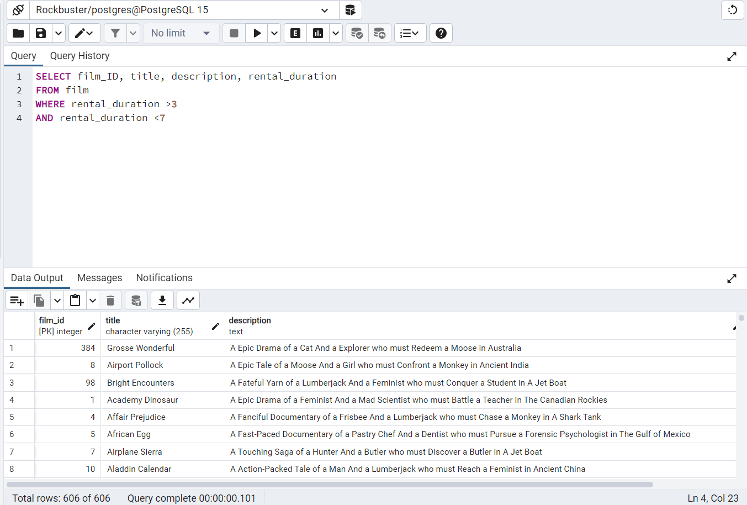1.c Rental duration is between 3 and 7 days (where 3 and 7 aren’t inclusive)

1.d Film replacement cost is less than 14.99

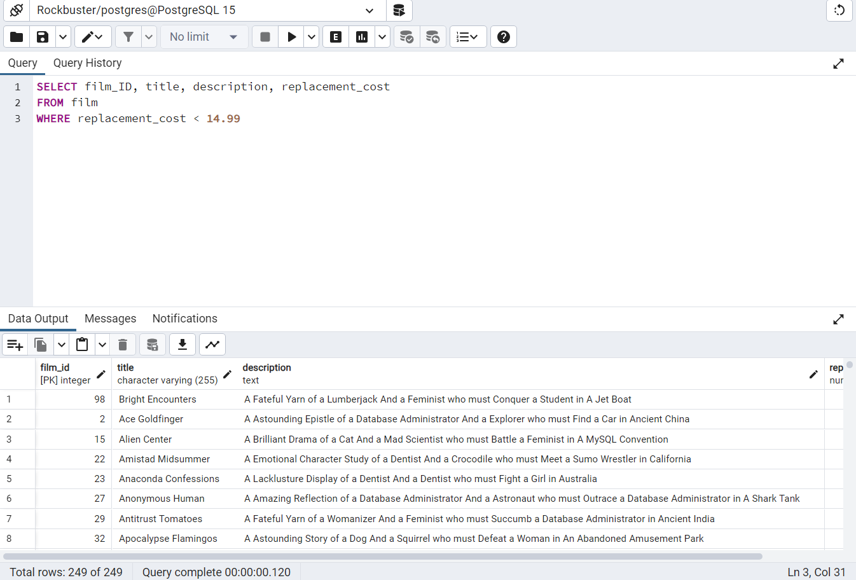

1.e Film rating is either PG or G

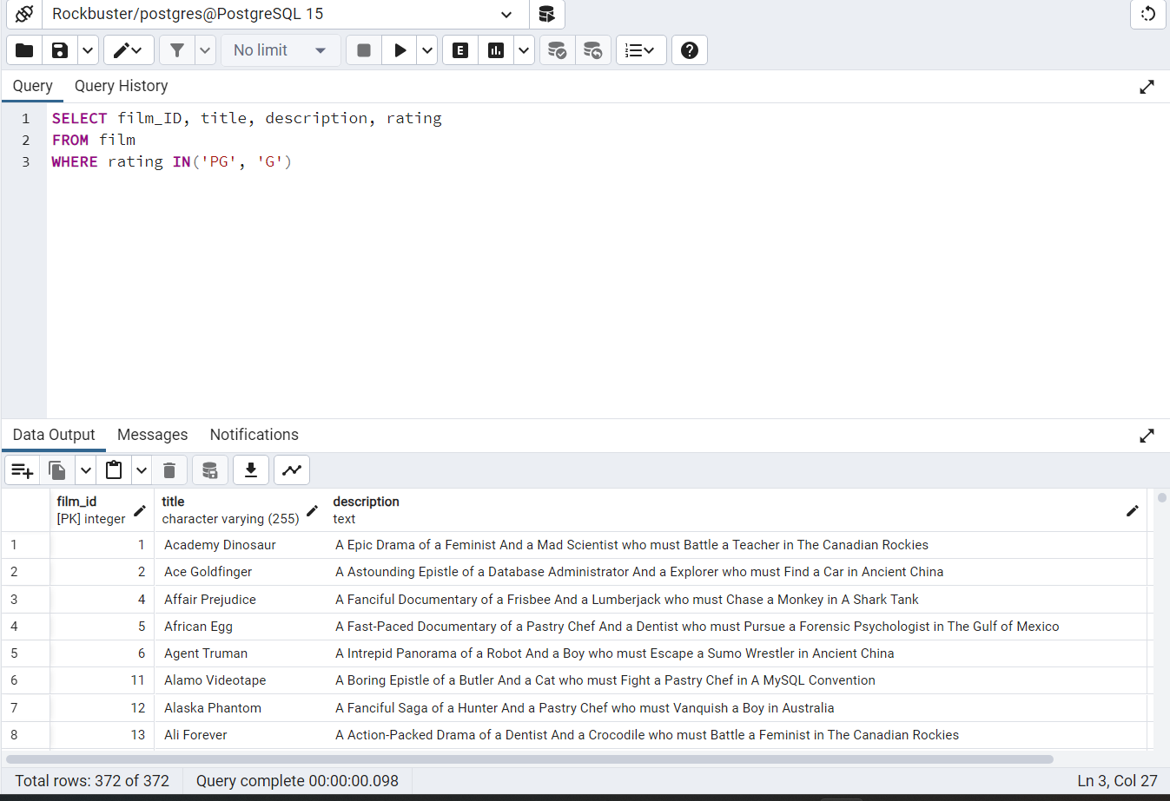

3.b The average rental rate is 2.97

3.c Maximum Rent Duration is 7

3.d The Minimum Rent Duration is 3

3.e To make this easier for coworkers.

4.

